**Service Request Management**

Service Request Module - Requirement Document

**Version** : 1.0

Author : Ojas Barpande

Date : 26/8/2020

**1. Purpose and Scope**

* The idea behind this project is to develop a solution which enables the employees of the organization to raise requests for services required and respond to the raised requests in an organized way.
* This document describes the technical requirements for the Service Request Module of the Service Request Management (SRM) project.
* This module covers the following aspects of the project

1. Creation of Service Requests
2. Display of Service Requests

* The SRM project is intended to be used internally by associates of SE2

**2. Executive Summary**

**2.1 Product Description**

* The Service Request Management project allows employees of the organization to raise requests for services that are required by them.
* The requests are then reviewed by the admins of the departments that the requests belong to and further assigned to the resource person within that department.
* An email is sent to the employees regarding the status of their requests.
* The resource persons then resolve the requests.

**2.2 Product Functions**

* Users will login to the service application and open the user dashboard page.
* User selects the “create service request” menu.
* Users will be able to view service request form.
* Users fill the form and the application will create the service request.

**2.3 User Classes**

* **Associate :** Associates can only create requests and view the requests created only by themselves.
* **Admins :** Admins can view the requests corresponding to their departments only. Admins have the option to change the status of the requests and assign the request to the respective resource person for resolution.
* **Resource Person :** The resource persons can view the requests assigned to them by the Admin and respond to the request accordingly.

**2.4 Operating Environment**

* This project is to be deployed as a web app accessible from browser irrespective of the operating system

**2.5 Design Constraints**

* **Frontend** : Angular 9, Bootstrap, Angular Material
* **Database** : Microsoft SQL Server
* **Backend** : ASP.NET Core

**3. Requirements**

**3.1 Dashboard Screen**

* This screen will be visible to the associates once they login to the application.
* This screen will display the following data in a list.
* There should be an input box to filter the requests from a string that the user inputs.
* The number of requests belonging to each category (Completed, Closed and Pending) will be displayed in cards at the top of the page.
* There should be a button in the header that can be clicked to create a new request

|  |  |  |  |  |
| --- | --- | --- | --- | --- |
| Name | Data Type | Size | Values | Comments |
| Service Request No. | Integer | 10 |  |  |
| Department | Enum | 20 | IT, Admin, Finance, Other |  |
| Request Category | Enum | 20 | Hardware, Software, Travel Booking, Salary Issue |  |
| Request Sub Category | Enum | 20 | Laptop, Mouse, Keyboard,  International Travel Ticket, Salary Calculation |  |
| Summary | String | 250 |  | Display Short text and display complete summary on mouse click in popup |

**3.2 Service Request Form**

* The service request creation form should take following data from the users..
* There should be buttons to save or cancel the form.
* Use validation in the inputs.
* Following data must be taken from the user through the form.
* All the fields are required.

|  |  |  |  |  |
| --- | --- | --- | --- | --- |
| Name | Data Type | Size | Values | Comments |
| Department | Enum | 20 | IT, Admin, Finance, Other |  |
| Request Category | Enum | 20 | Hardware, Software, Travel Booking, Salary Issue | Filter the options according to the department selected |
| Request Sub Category | Enum | 20 | Laptop, Mouse, Keyboard,  International Travel Ticket, Salary Calculation | Filter the options according to the Request category selected |
| Summary | String | 250 |  |  |

**4. Workflow**

**4.1 Dashboard Screen**

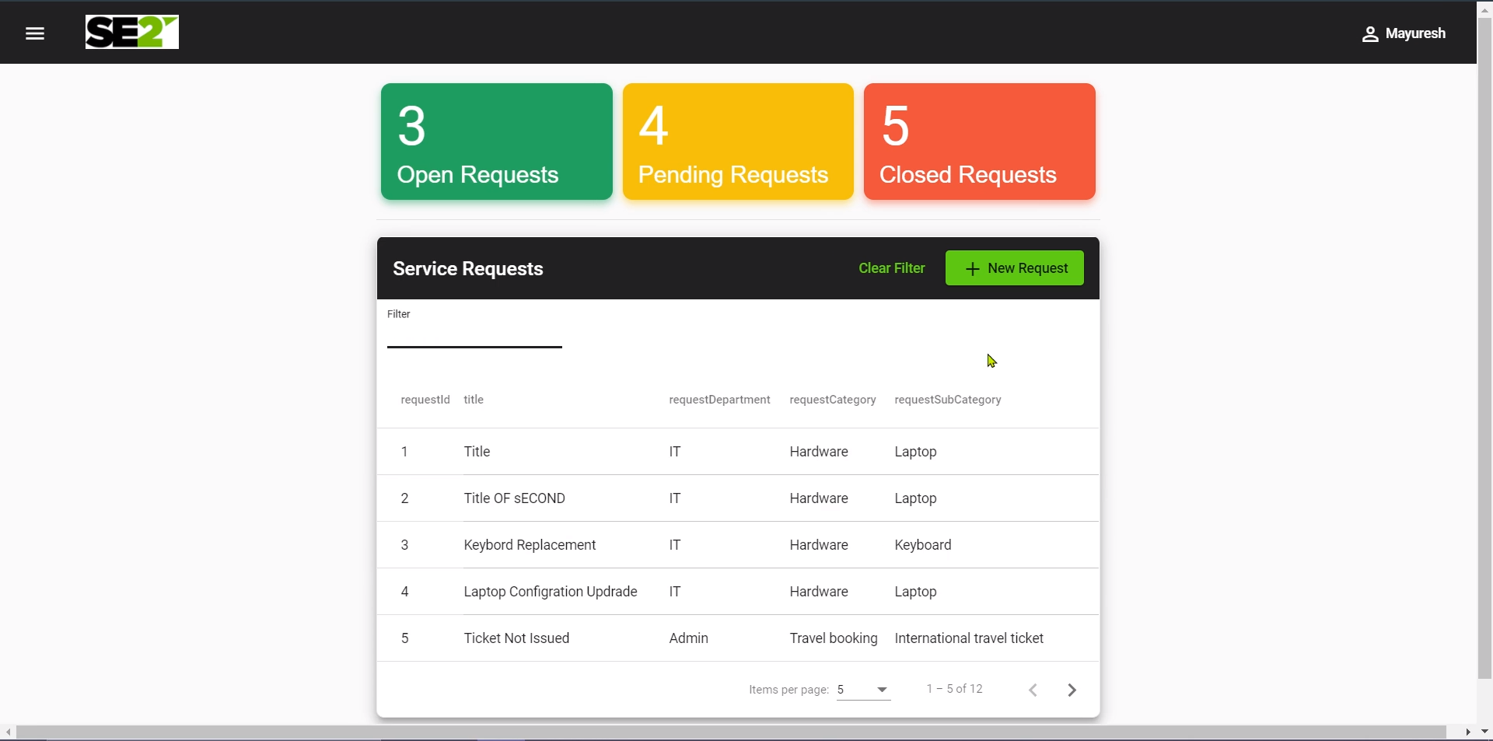

**4.2 Service Request Form**

